Sudoku Solver

User Instruction Manual

2020

Table of Contents

Download Visual Studio 2

Download Sudoku Solver 10

Using Sudoku Solver 15

# Download Visual Studio

## Step 1

From your desktop PC or the taskbar, launch your search engine of choice.

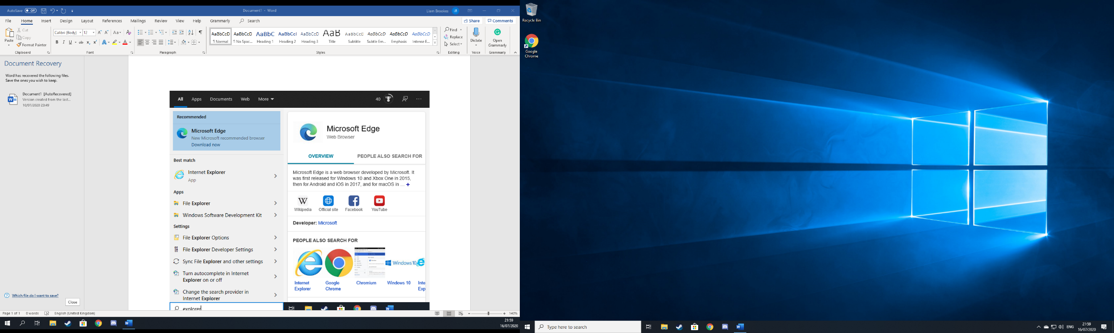

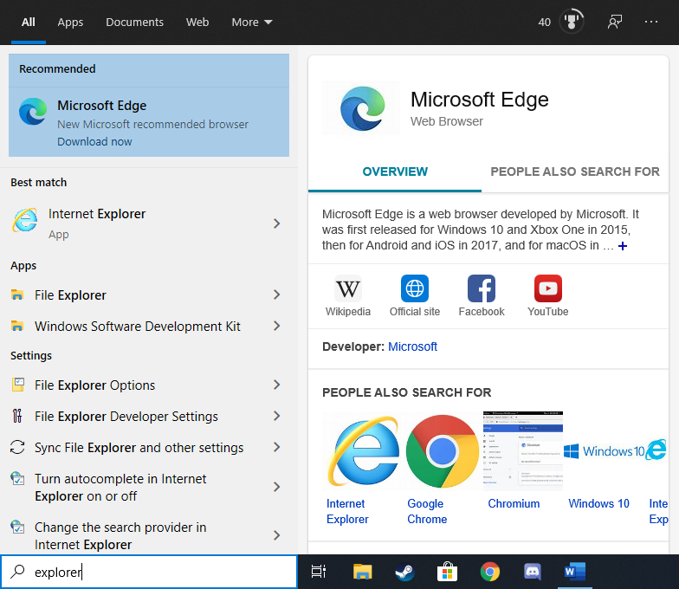

## Step 2

Once your search engine has launched, search for ‘*Download Microsoft Visual Studio*’ and select the first website or head over to

[https://visualstudio.microsoft.com/downloads/](https://visualstudio.microsoft.com/downloads/.)

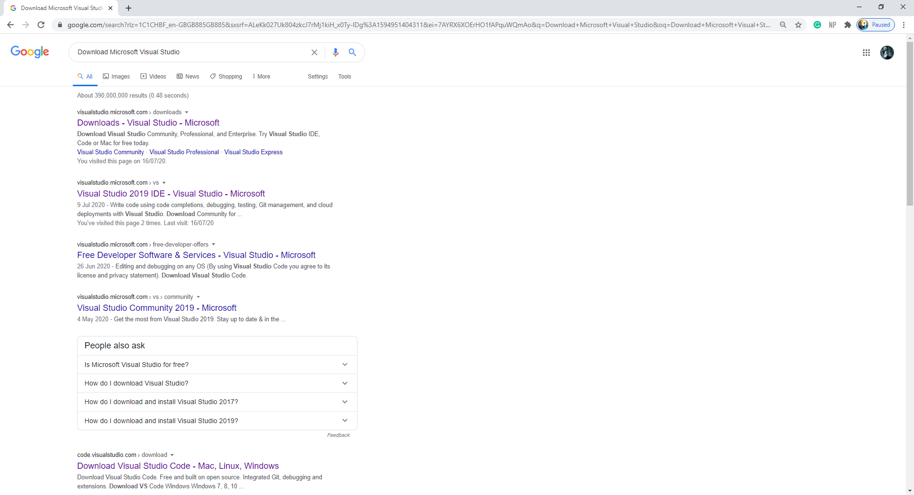

## Step 3

After the website has loaded click on the free download option under Community and wait for the download to complete.

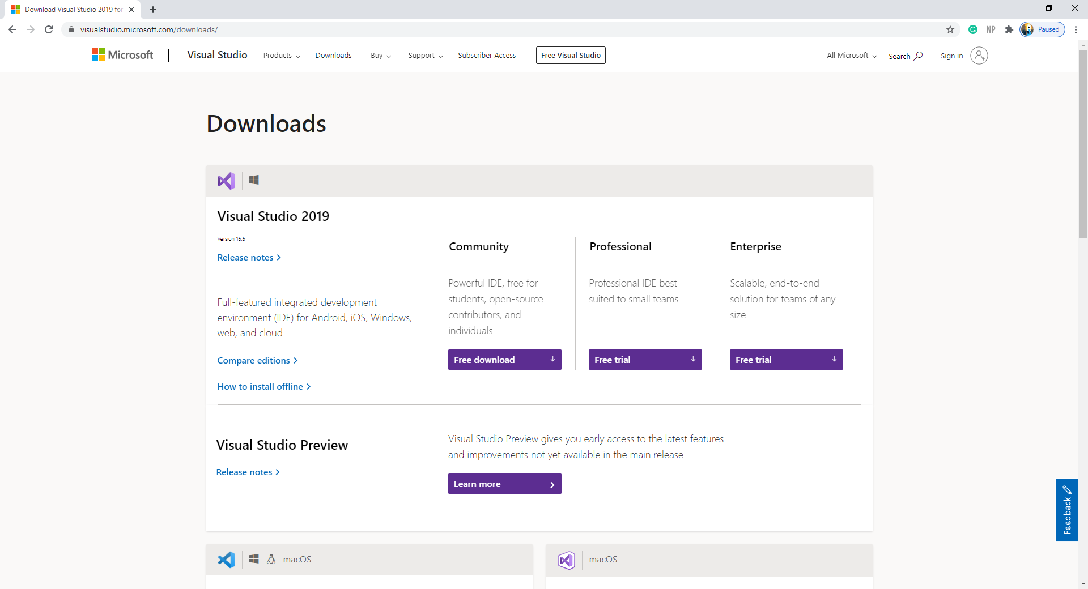

## Step 4

After the installation is complete launch the exe file from the download bar.

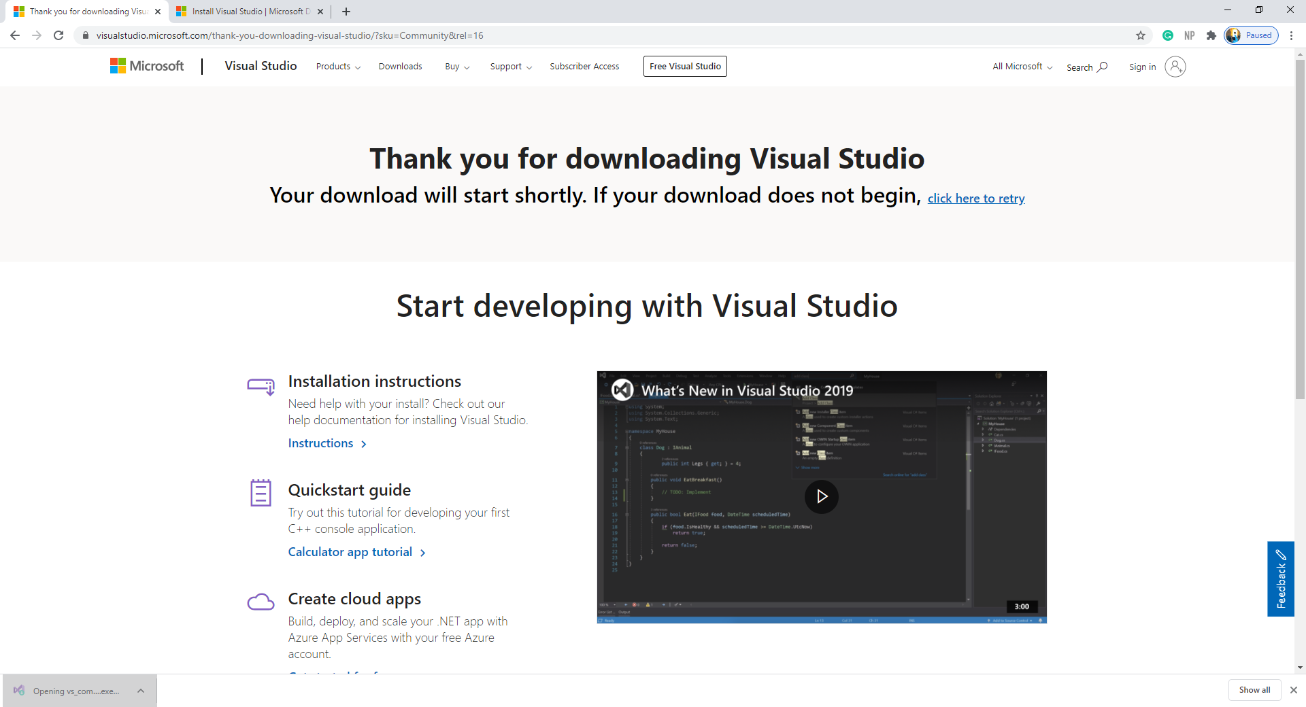

## Step 5

Once the Visual Studio installer screen launches, click on continue.

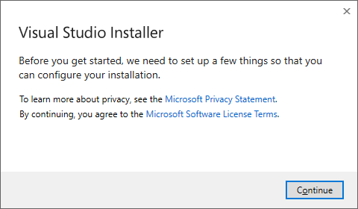

## Step 6

Wait for Visual Studio to download the required files.

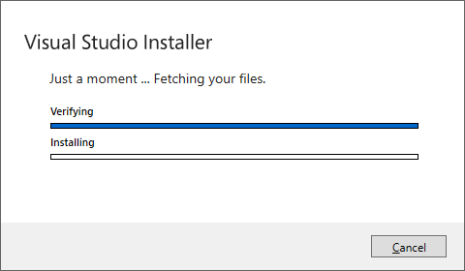

## Step 7

After the previous installation, you will be able to download the selected tools that Visual Studio offers. For Sudoku Solver you will need to select:

* APS.NET and web development
* .NET desktop development

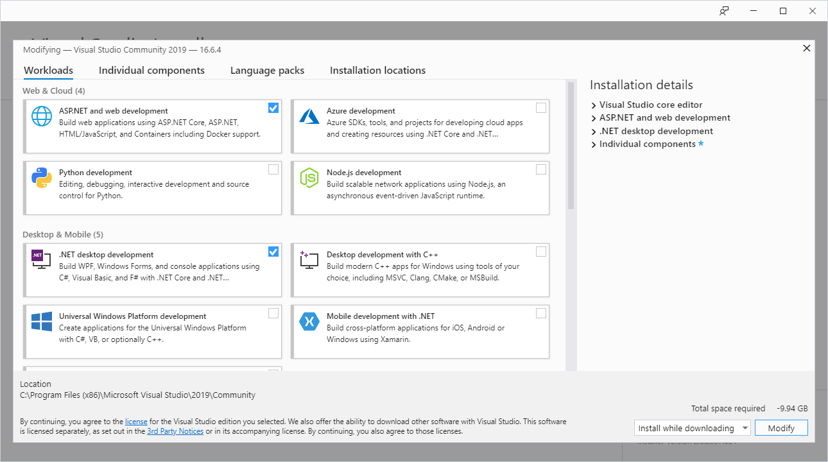

## Step 8

Then click install and wait for the installation to complete. Once complete you will be prompted to reboot your PC.

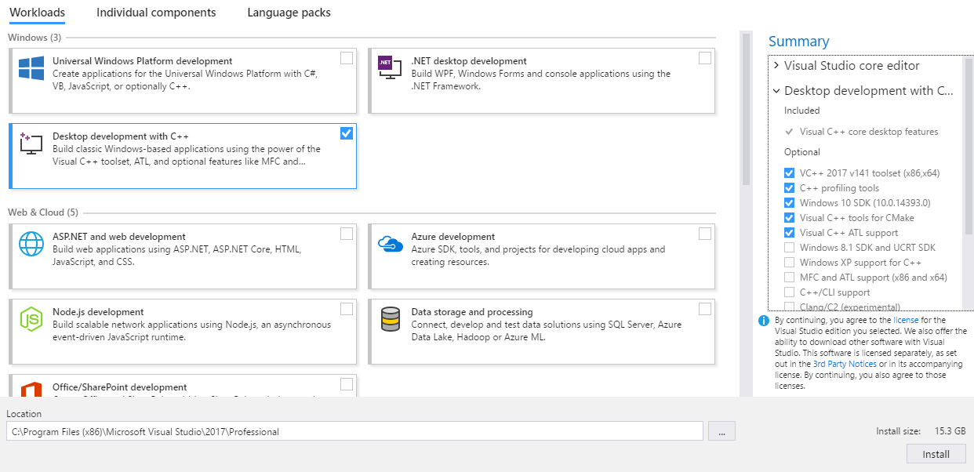

# Download Sudoku Solver

## Step 1

From your search engine head to the following link:

<https://github.com/LiamBrookes/Sudoku-Solver>

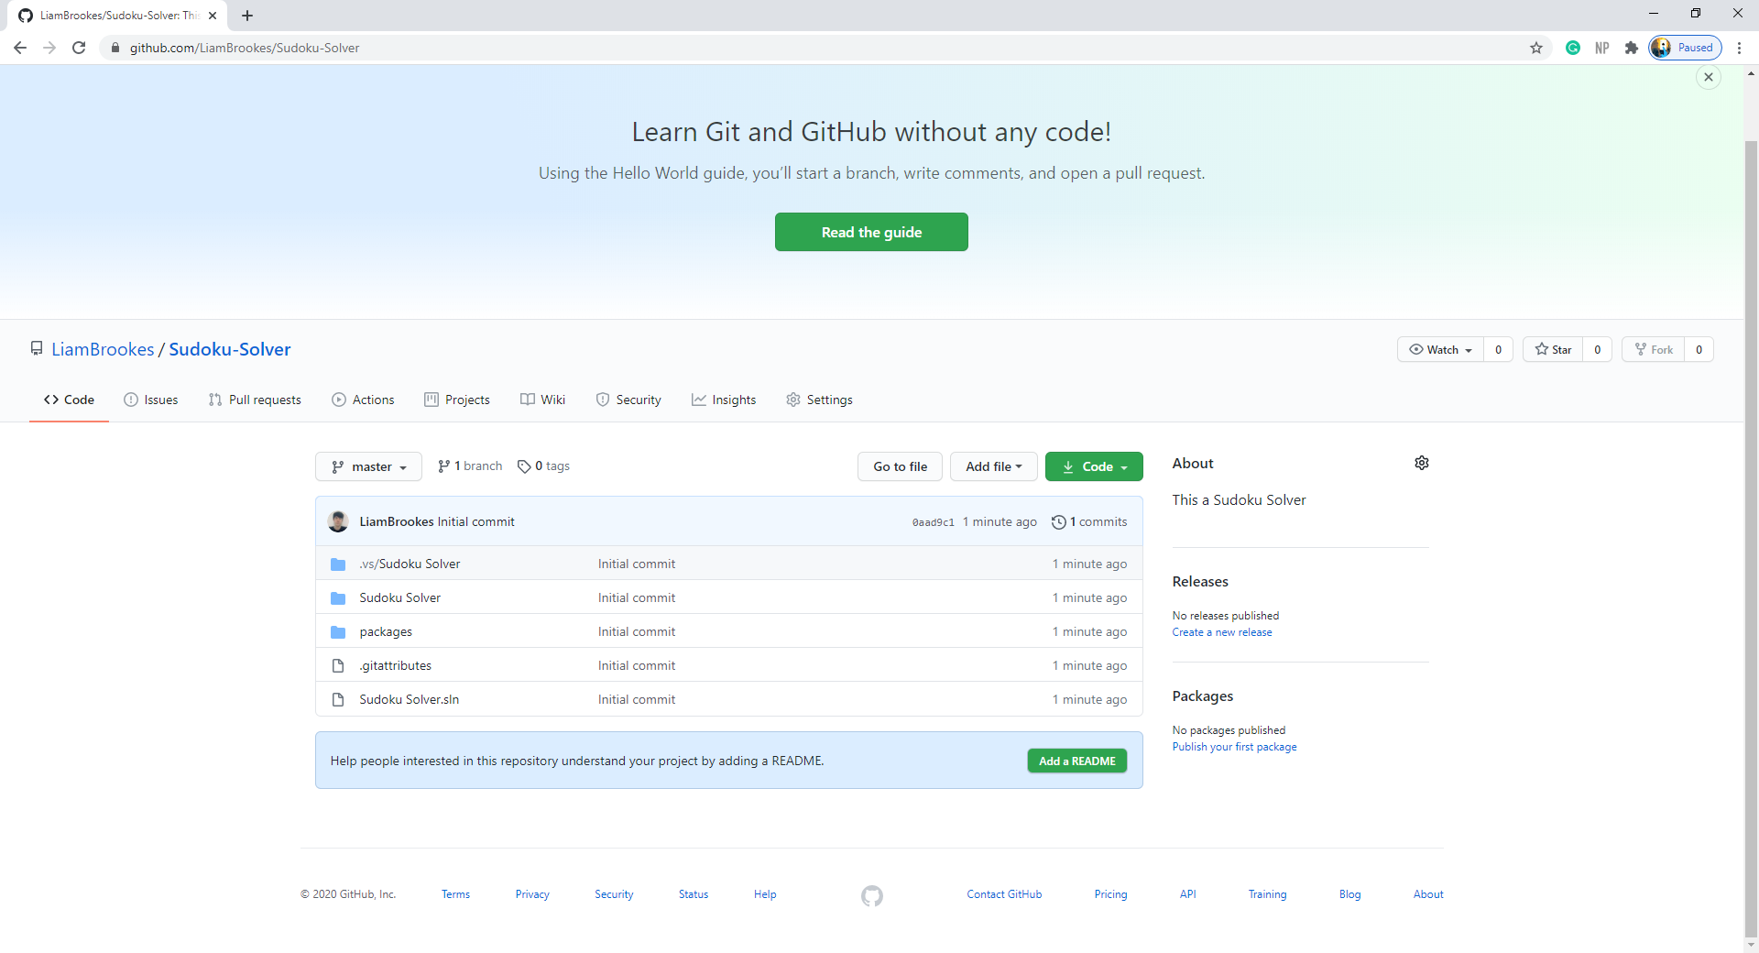

## Step 2

Once on the GitHub page, click on the download ‘Code’ button and then click on the ‘Download ZIP’ option.

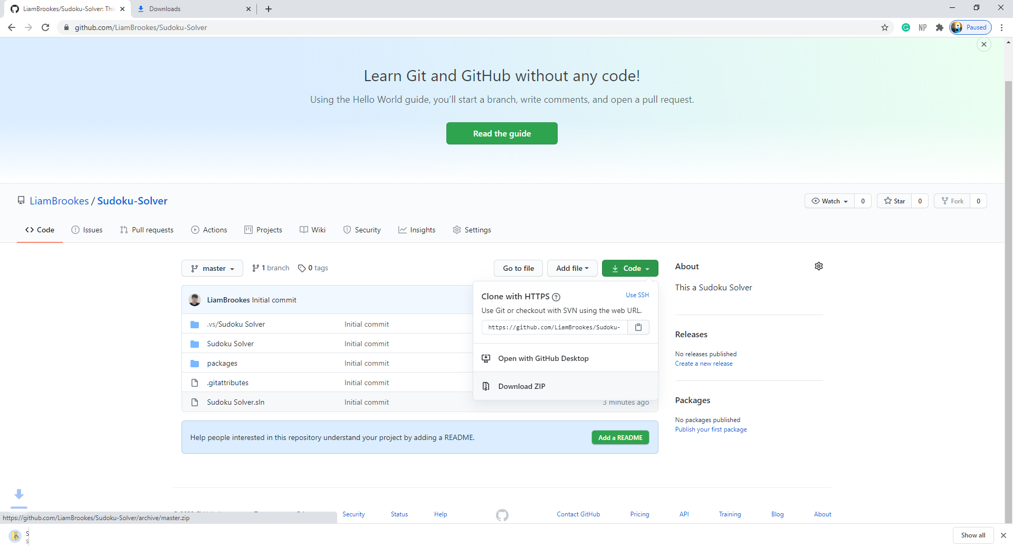

## Step 3

Wait for the file to install.

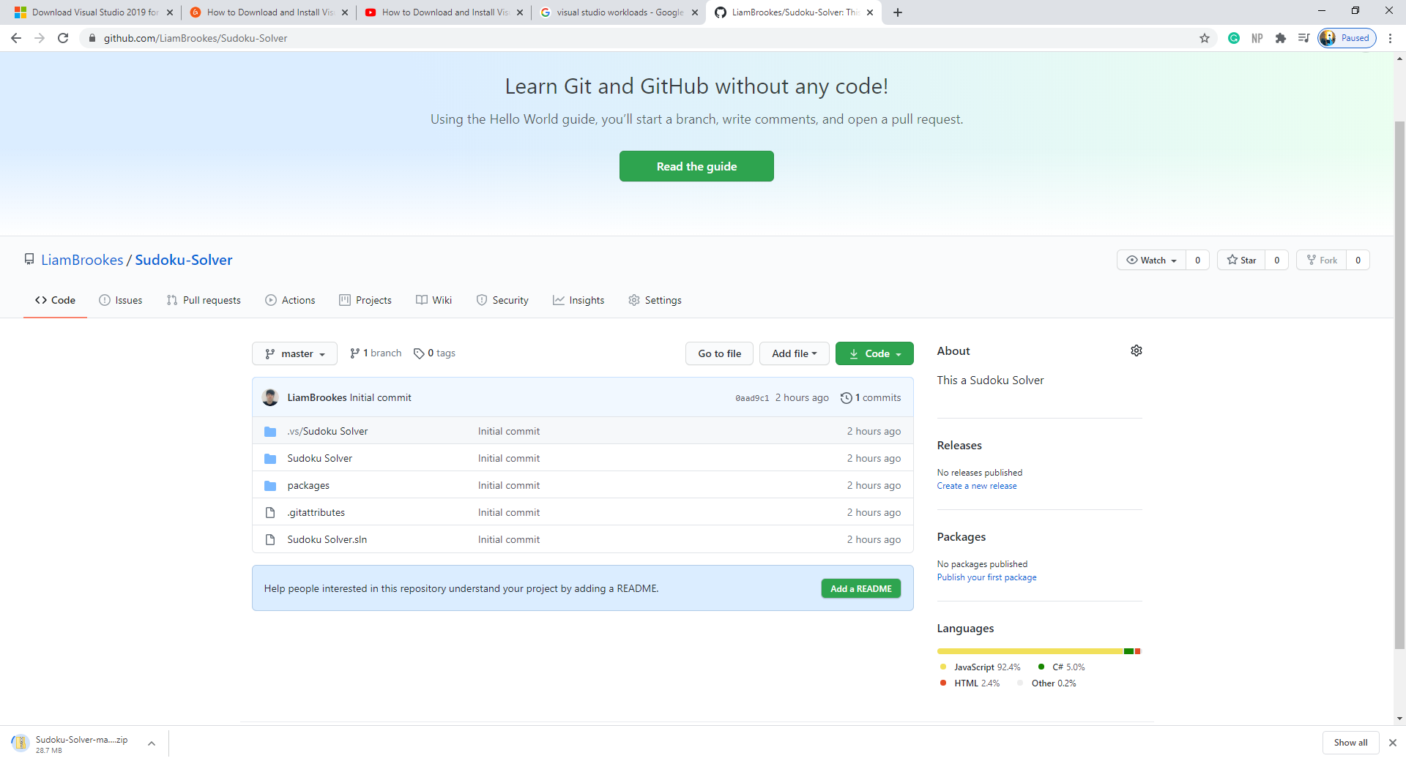

## Step 4

Once the file has downloaded move it to a suitable location, then right-click on it and select extract.

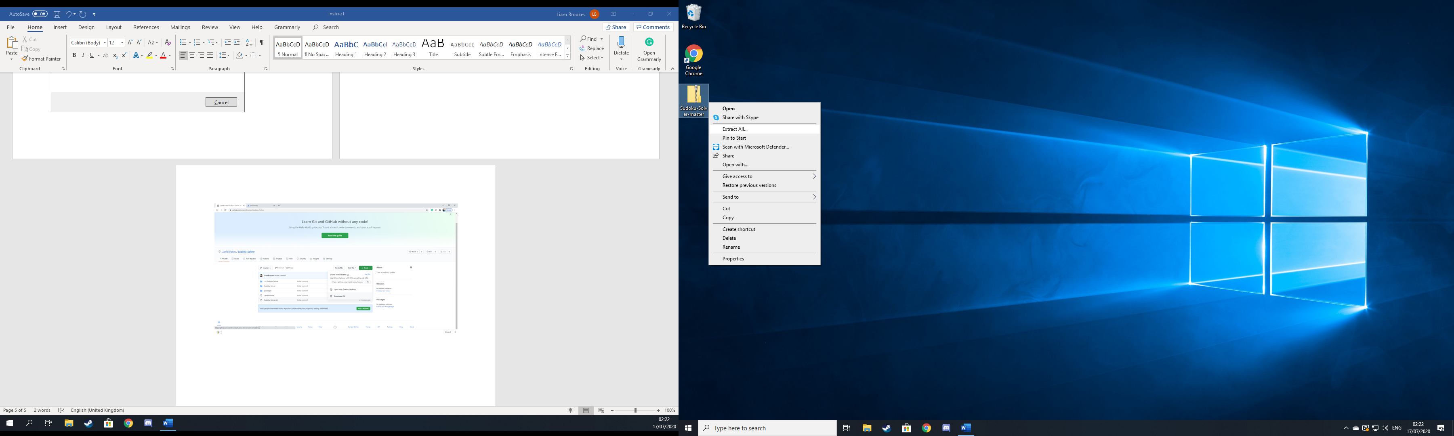

## Step 5

Once the contents have been extracted open the file, double click on ‘Sudoku-Solver-master’ and then right-click on the Visual Studio solution and go to open with and then select your visual studio version of choice.

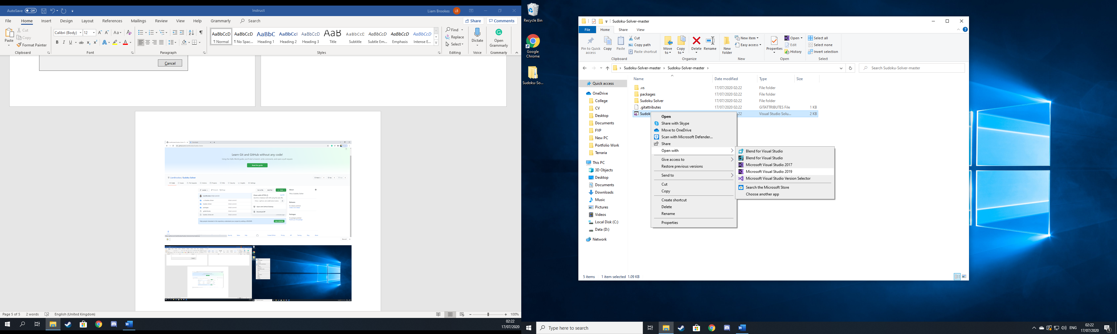

# Using Sudoku Solver

## Step 1

After launching Sudoku Solver in Visual Studio, click on the drop-down menu at the top and select the web browser you would like to launch sudoku solver with.

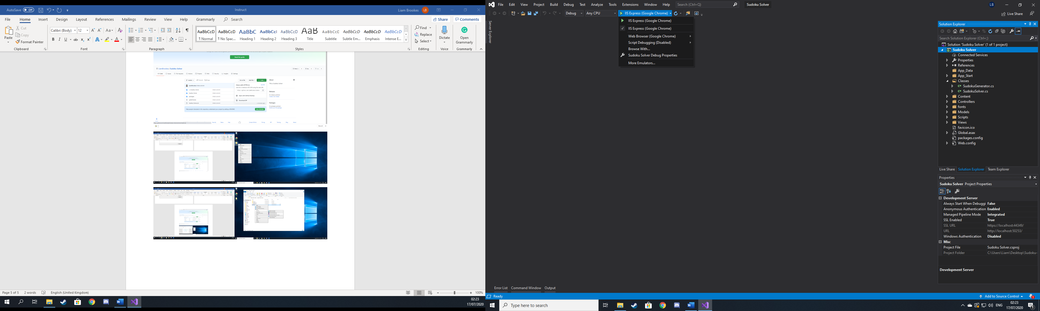

## Step 2

Once the web browser launches, click on the sudoku solver tab on the navigation bar located at the top.

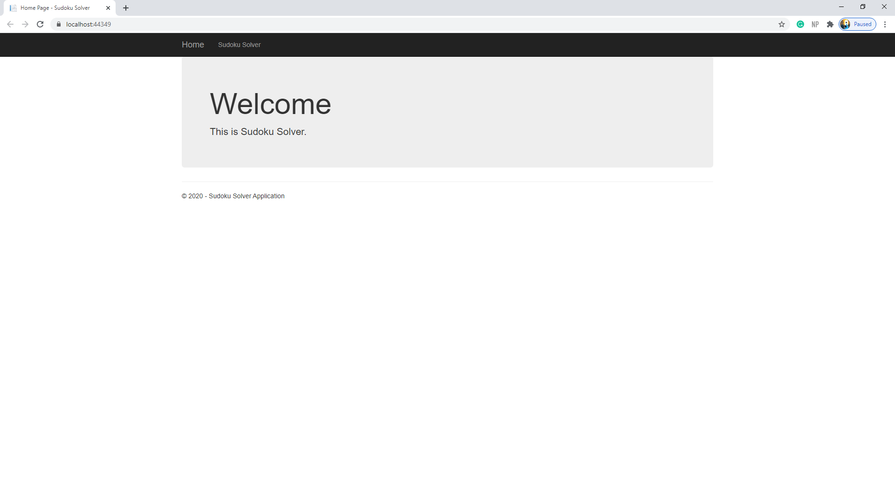

## Step 3

When on the sudoku solver page start to enter your problem into the corresponding locations leave any unknown values as 0, or you can generate a problem for demonstration purposes by click on the ‘Generate’ button.

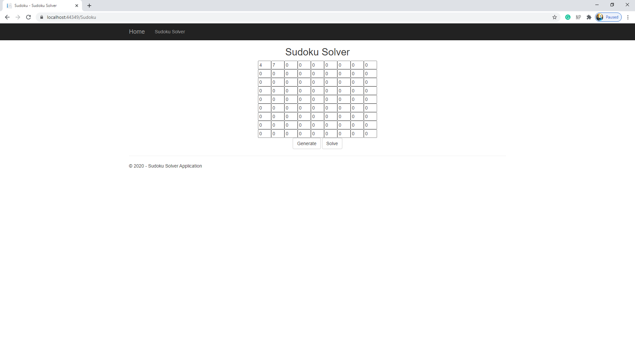

## Step 4

Once you have either ented in your problem or generated one, click solve.

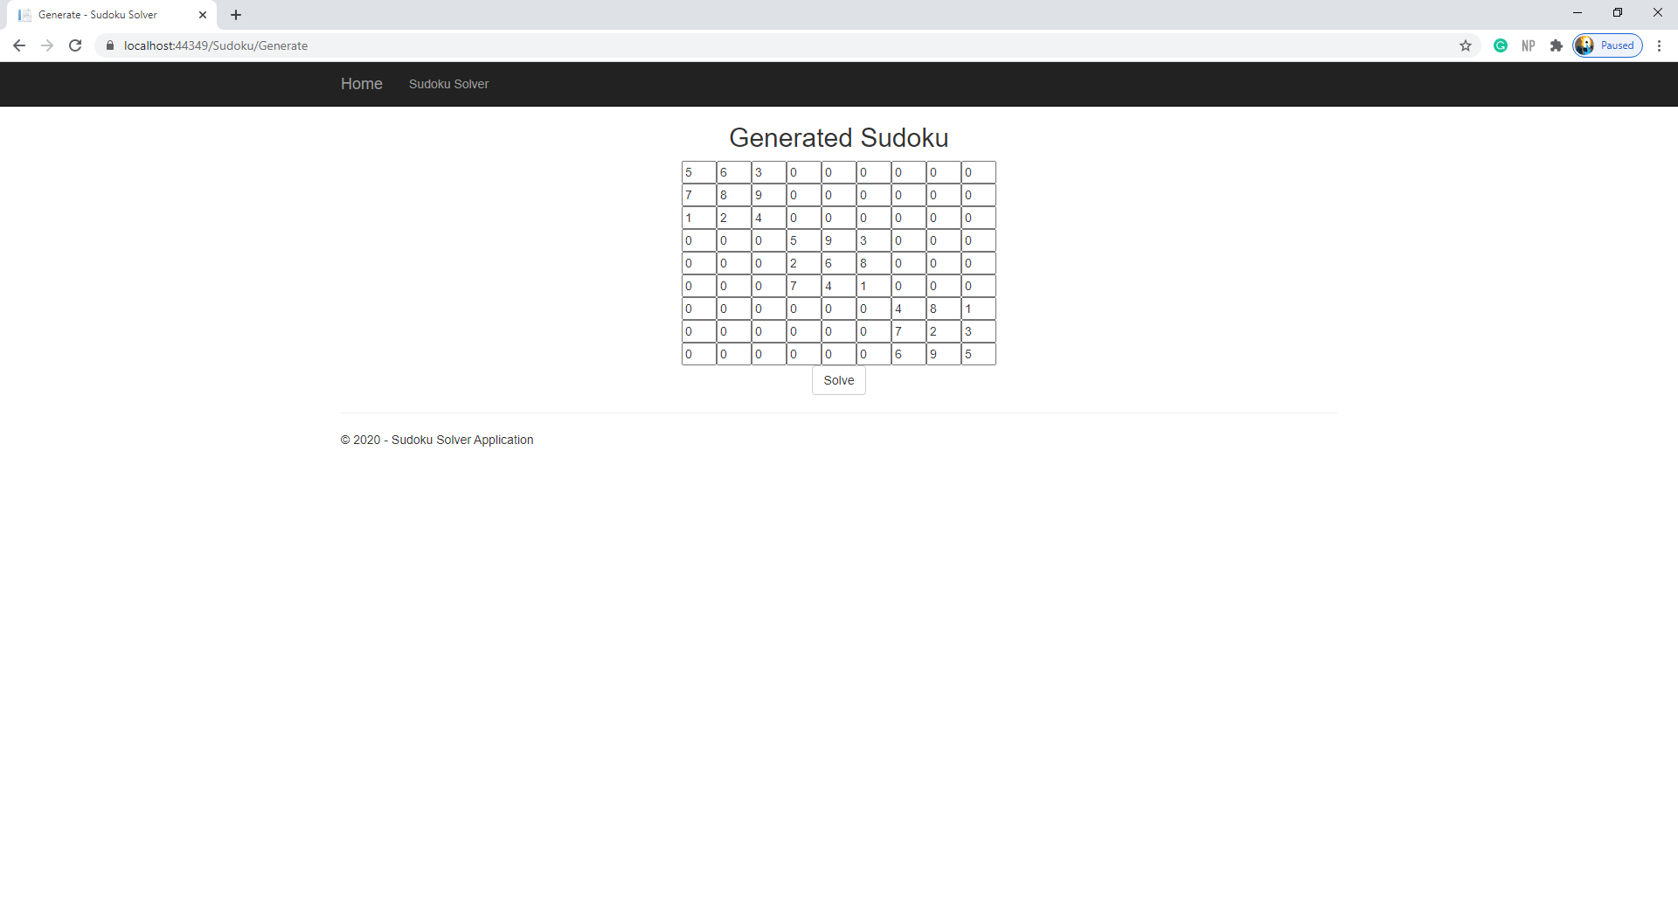

## Step 5

Finally, you will have the solved solution to your problem.

